

**University of Macau**

**CISC 3003 Web Programming**

**Project Assignment – Individual Portion**

DC125222 Lee Cheok Hin

# Abstract

As the pace of life is faster and faster, people have less and less time to eat a meal. Therefore, the food order platform becomes a good helper for them. This is a food order website that cover frontend and backend web application design and it is credited to Vijay Thapa.

This food order website can let website administrators manage their website easily. By using this website, the admins can manage (add, update, delete) the food menu via an intuitive interface. Also, they can manage the admin accounts via this website. Moreover, on the side of customers, can search for the food they want and make orders on this website. Besides, this website is developed in different languages, including HTML, CSS, and PHP. Furthermore, MySQL is exploited to manage the database, and for database protection, the website’s inputs are protected from SQL injection to prevent malicious or accidental input. Therefore, this website will be a good assistant for administrators and a time-saver for customers.

# List of Services

* **Administrator**
  1. Login to admin page
  2. Manage (Add/update/remove) admin accounts
  3. Manage (Add/update/remove) food categories
     1. Manage the featured category display on home page
     2. Manage the food category display on all food page
  4. Manage (Add/update/remove) foods

1. Manage the featured food display on home page
2. Manage the foods display on foods page
   1. Update the customers’ orders
      1. Update the info of the orders (quantities, status, customer information)
   2. View data (number of categories, foods, orders, total revenue) on admin page

* **User**
  1. Search the food in the website
  2. Make orders on different foods
* **System**
  1. Protect the database from SQL injection

# List of Tasks

1. Use session to block users from entering the admin pages without logging in
2. Create index.php as a dashboard page for admin with displaying information (number of categories, foods, orders, total revenues) of the website.
3. Prevent users from directing to different pages without necessary query strings
4. Manage Admin Accounts
5. Create manage-admin.php to give an interface that lists all of the admin accounts and the information in the database with links to add, update, delete, password changing pages.
6. Create update-admin.php to update the information of the accounts in database, and send back a message of success or fail.
7. Create delete-admin.php to delete the accounts from database, and send back a message of success or fail.
8. Create add-admin.php to add accounts to database, and send back a message of success or fail.
9. Manage Categories
   1. Create manage-category.php to give an interface that lists all of the categories and the information in the database with links to add, update, delete pages.
   2. Create update-category.php to update the information of the categories in database, and send back a message of success or fail.
   3. Create delete-category.php to delete the categories from database, and send back a message of success or fail.
   4. Create add-category.php to add categories to database, and send back a message of success or fail.
10. Manage Foods
    1. Create manage-food.php to give an interface that lists all of the foods and the information in the database with links to add, update, delete pages.
    2. Create update-food.php to update the information of the foods in database, and send back a message of success or fail.
    3. Create delete-food.php to delete the foods from database, and send back a message of success or fail.
    4. Create add-food.php to add foods to database, and send back a message of success or fail.
11. Manage Orders
    1. Create manage-order.php to give an interface that lists all of the orders and the information in the database with links to update page.
    2. Create update-order.php to update the information of the orders in database, and send back a message of success or fail.
12. Website
    1. List at most 3 featured and active categories on home page
    2. List at most 6 featured and active foods on home page
    3. List all active categories on categories page
    4. List all active foods on foods page
    5. User can search the foods by inputting keywords
    6. User can make orders to different foods
13. Protect the database from SQL injection

# Accomplishments

1. Use session to block users from entering the admin pages without logging in

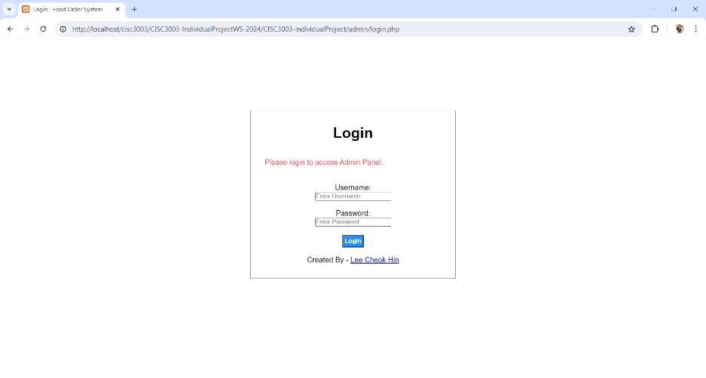

1. Create index.php as a dashboard page for admin with displaying information

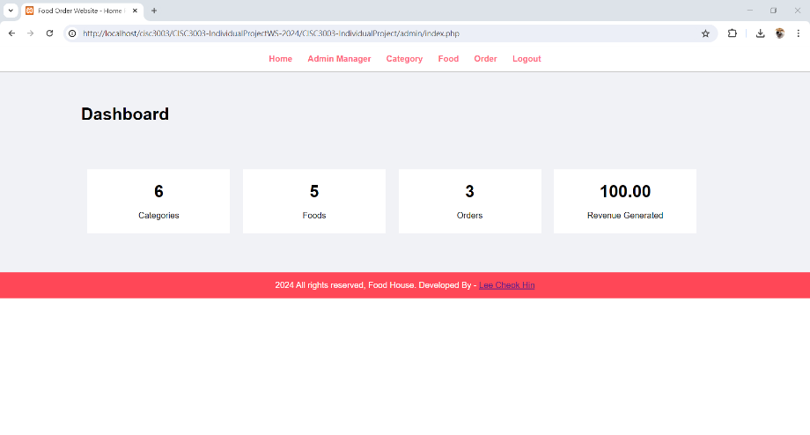

1. Prevent users from directing to different pages without necessary query strings

* For example, if we direct to category-foods.php without “category_id” query strings, it will redirect to the home page.

1. Manage Admin Accounts

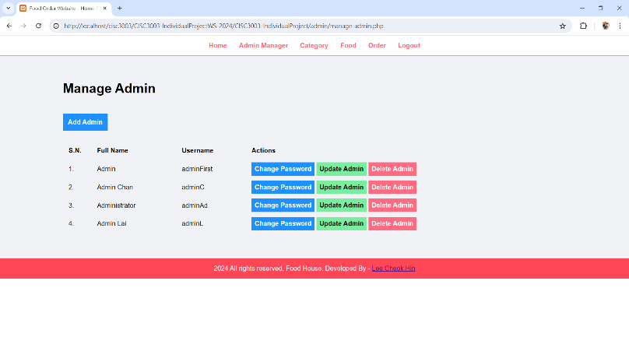

1. Manage Categories

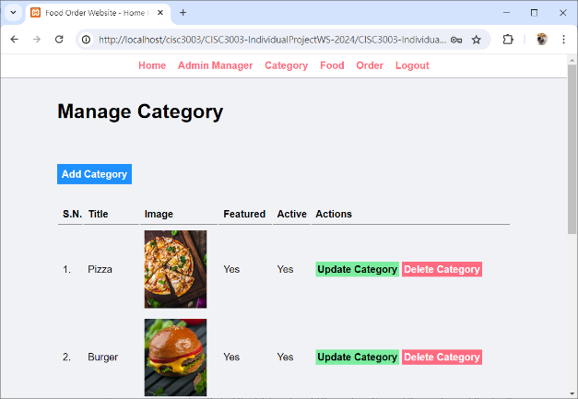

1. Manage Foods

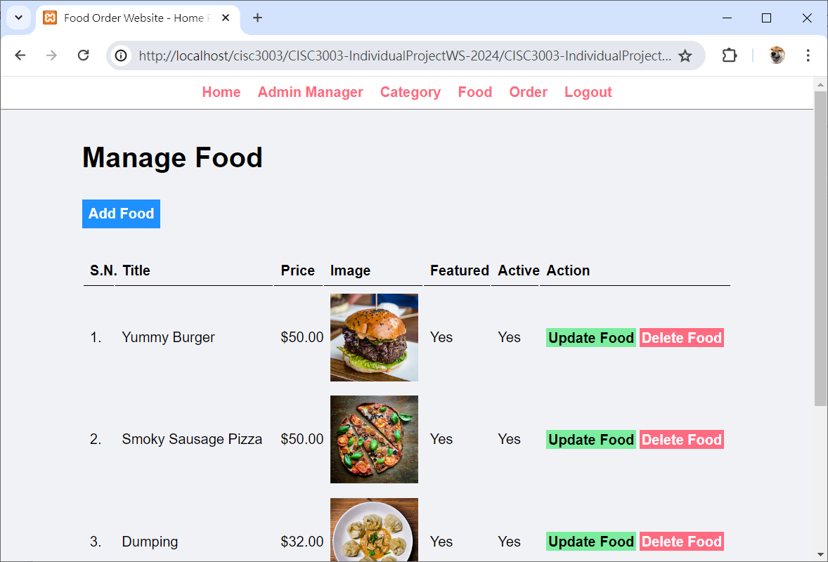

1. Manage Orders

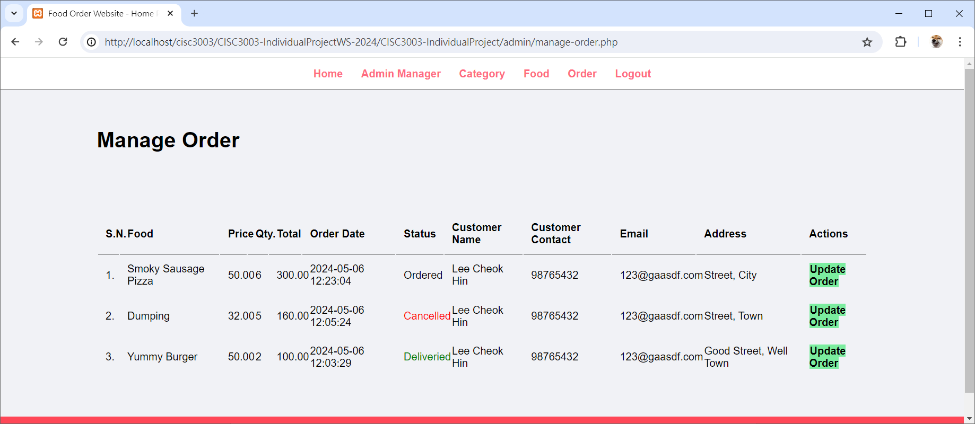

1. Website

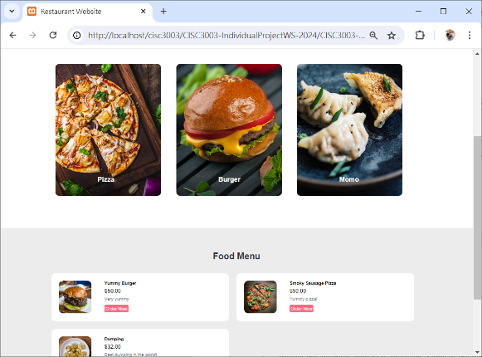 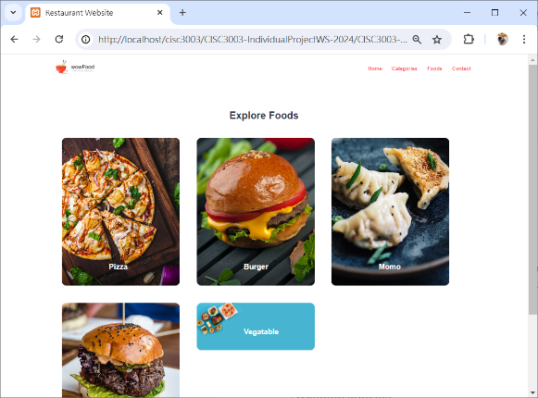

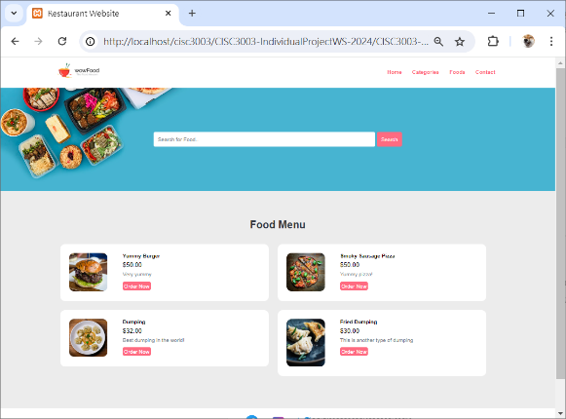 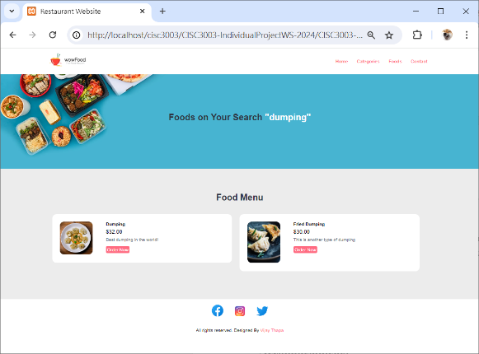

1. Preventing from SQL injection

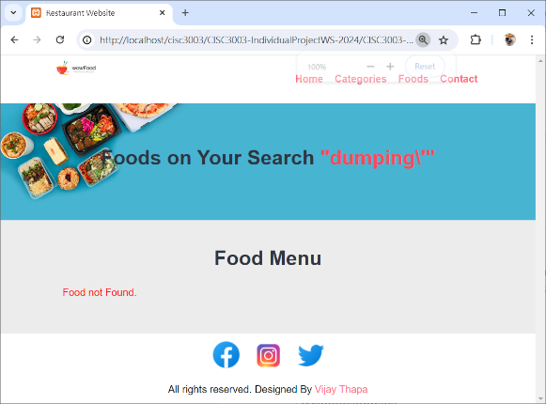

# Incomplete

1. Protect the database from SQL injection. Some of the inputs (e.g. input in manager-add.php, manager-update.php) are still not getting protect from SQL injection. Malicious input may deal a serious impact on the database.
2. Username duplication. The username of the admin accounts can be duplicated. It will cause some problems during login, such as the same username and password but a different account ID.
3. Empty information account can be created. An account that with blank full name, username and password can be created. We should prevent the creation of this kind of accounts.